**REMOTE ACCESS -TUTORIAL**

**MobaXterm, Public Key Authentication and .bashrc Settings**

**MobaXterm CLIENT -TUTORIAL**

1. **MobaXterm Installation**
2. Download MobaXterm from <https://mobaxterm.mobatek.net/download.html>
3. Install it with default settings.
4. **MobaXterm Configuration**
5. Click on "Sessions" and then on "SSH".

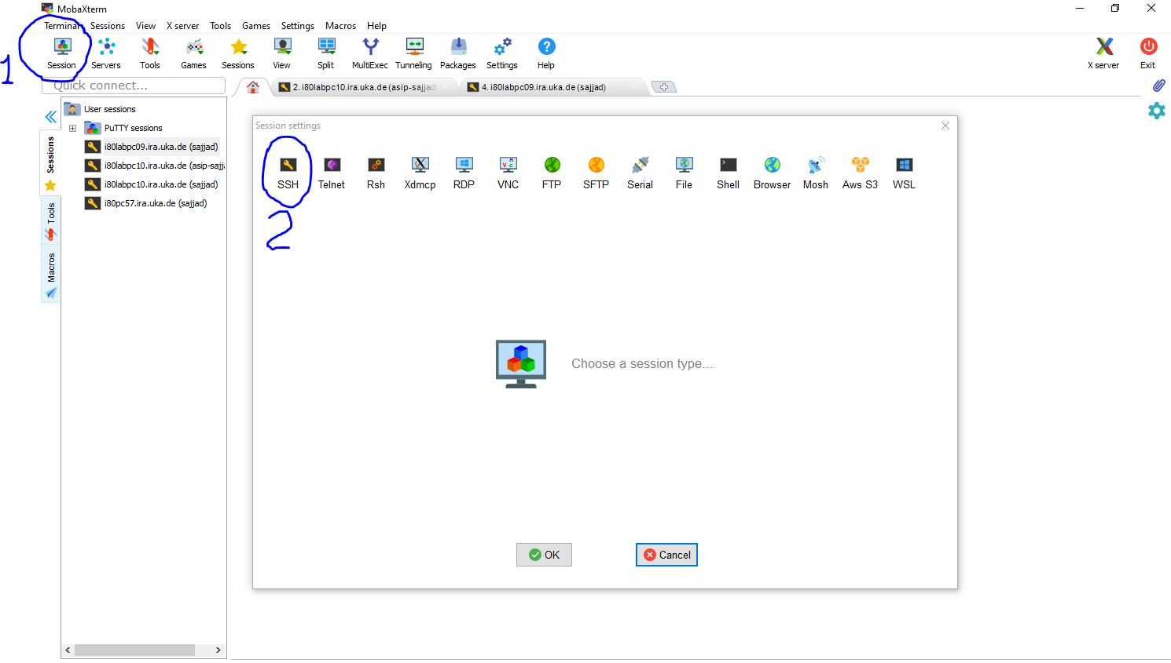

Figure : SSH Session

1. In the new windows "Session settings", enter **Remote host** as “*i80labpcXX.ira.uka.de*”, tick the box "**Specify user name**" and then enter your user name as “*asip-abcdnn*”.

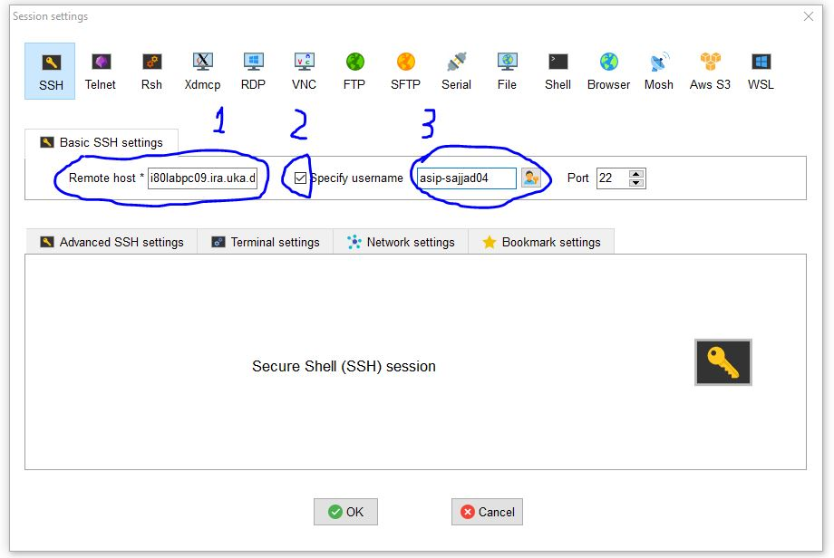

Figure : Session Settings

1. Press OK. It will ask for the user password.
2. Enter your password and press Enter.

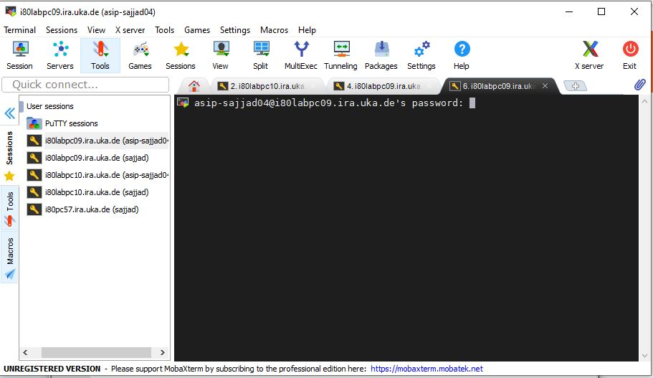

Figure : Logging in and Requiring Password

1. You are now logged into the lab PC using MobaXterm.

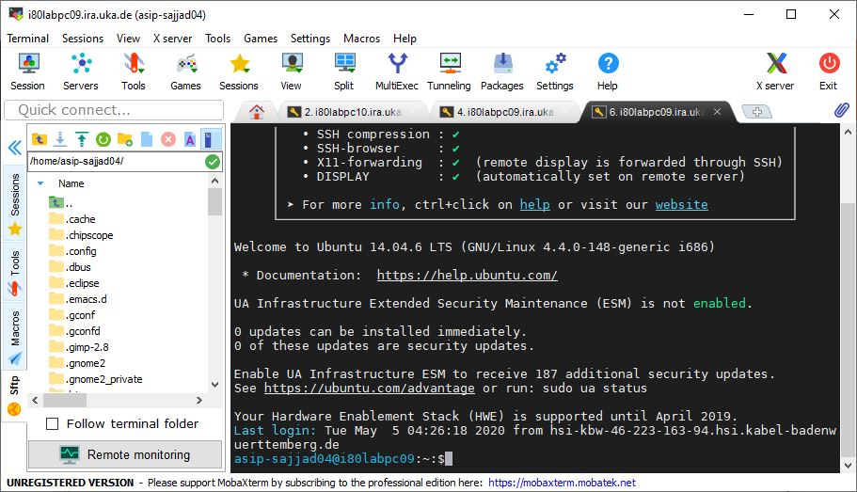

Figure : Logged into Remote PC

1. **Recommended Practice.**
2. It is **recommended** to log into **i80pc57** as this PC contains the ASIPmeister software. Try to perform lab on this PC. Use **i80labpc10** when you need to implement your applications on FPGA.
3. To repeatedly login to some PC and avoid password, use DSA-keys and copy to desired PC.
4. Type "**ssh-keygen -t dsa**" and press Enter. Leave the default options. Leave the password empty.

asip-sajjad04@i80labpc09:~:$ssh-keygen -t dsa

Generating public/private dsa key pair.

Enter file in which to save the key (/home/asip-sajjad04/.ssh/id_dsa):

/home/asip-sajjad04/.ssh/id_dsa already exists.

Overwrite (y/n)? y

Enter passphrase (empty for no passphrase):

Enter same passphrase again:

Your identification has been saved in /home/asip-sajjad04/.ssh/id_dsa.

Your public key has been saved in /home/asip-sajjad04/.ssh/id_dsa.pub.

The key fingerprint is:

af:c3:84:62:4e:f4:e6:5e:cb:d1:03:19:ff:63:a9:ad asip-sajjad04@i80labpc09

The key's randomart image is:

+--[ DSA 1024]----+

| |

| |

| . |

| . + |

| . . .S . |

| + + .+ . . |

| + + oo + = |

| . .oo+ = . |

| .. +.E.. |

+-----------------+

1. Then copy this generated DSA-key to desired PC by type following command and enter your password.

asip-sajjad04@i80labpc09:~:$ssh-copy-id -i ~/.ssh/id_dsa.pub asip-sajjad04@i80pc57

/usr/bin/ssh-copy-id: INFO: attempting to log in with the new key(s), to filter out any that are already installed

/usr/bin/ssh-copy-id: INFO: 1 key(s) remain to be installed -- if you are prompted now it is to install the new keys

asip-sajjad04@i80pc57's password:

Number of key(s) added: 1

Now try logging into the machine, with: "ssh 'asip-sajjad04@i80pc57'"

and check to make sure that only the key(s) you wanted were added.

1. Now log into i80pc57 using “ssh -X” it will ask for the password.

asip-sajjad04@i80labpc09:~:$ssh -X i80pc57

Last login: Wed May 6 05:11:07 2020 from i80labpc09.irf.uni-karlsruhe.de

asip-sajjad04@i80pc57:~:$

1. **Setting up .bashrc.user**
2. Whenever you are logged into any PC, this file is executed at the login. Please set different variables in this file carefully. Usually the following variables should be like this:

asip-sajjad04@i80pc57:~:$cat .bashrc.user

export ASIPS_LICENSE=29000@i80asip.ira.uka.de

export PATH=/AM/ASIPmeister/bin:$PATH

export ASIP_APDEV_SRCROOT=/home/asip00/epp/AM_tools

export PATH=/usr/java/jre1.6.0_45/bin:$PATH

export ASIPmeister_Home=/AM/ASIPmeister

export ASIPmeister_HOME=/AM/ASIPmeister

. /home/adm/modelsim_66d.setup

. /home/adm/xilinx_13.2_32bit.setup

asip-sajjad04@i80pc57:~:$